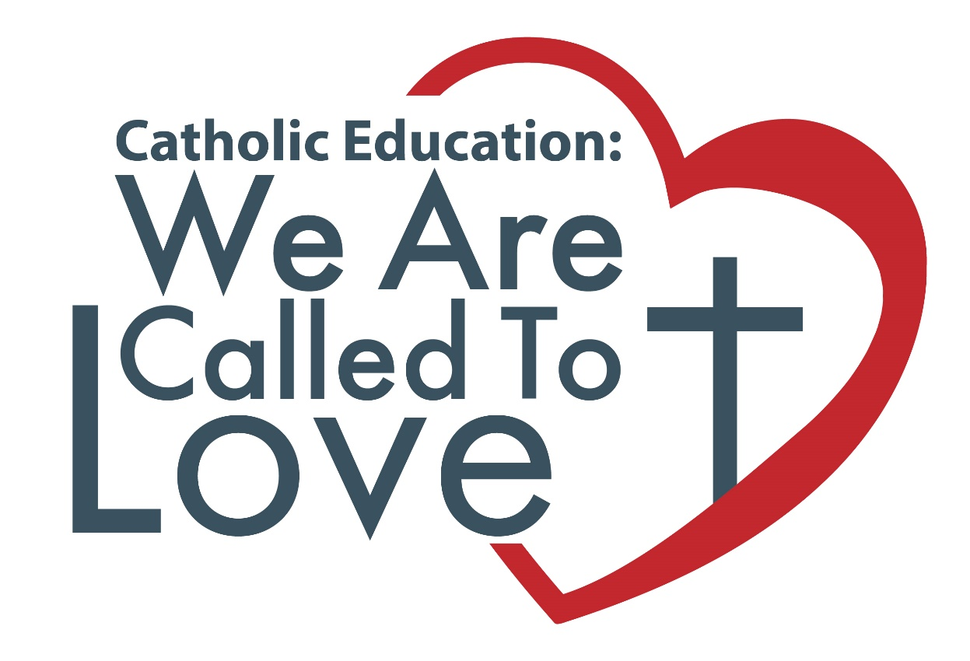

COMMUNITY RESOURCES &
SAMPLE TEMPLATES

These resources are designed for parishes, administrators, teachers and other members of school communities.

“If we love one another, God lives in us.” (1 John 4:12)

CATHOLIC EDUCATION WEEK
MAY 5 – MAY 10, 2024
WWW.GOODNEWSFORALL.CA

